**Code Analysis/White-box Testing**

*What are the three bugs and why doesn’t test find them?*

* 1. On line 28, you are setting “successfulMessages” variable to ***null*** (.isEmpty()). Therefore, on line 30 when you call that variable, you are passing a null. This is a business logic error. The test doesn’t find this error because although it is a null value we are passing here, it is a value nontheless. The test simply sees this as “oh, you passed a value to me where there needs to be a value”. We would need to pass “failedMessages” to “(currentUser, <variable>) in order to sucessfully add a recipient.

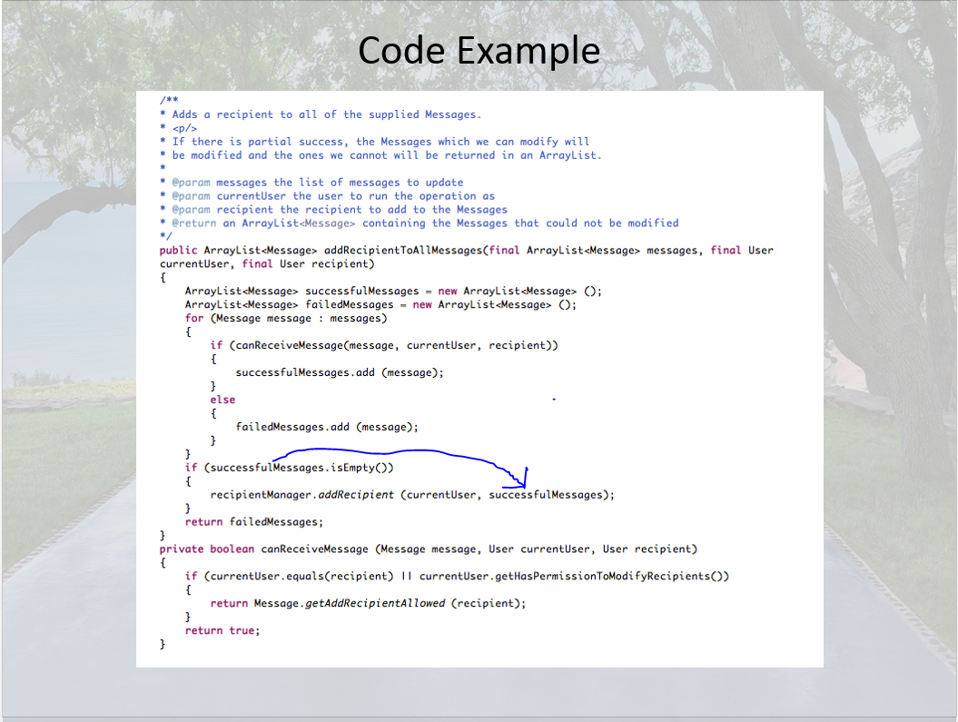

* 1. On line 30, “recipientManager” is never instantiated. This is a compilation error. The test does not catch this because it is still syntactically correct. Even though the syntax is correct, the compile will throw an error. We would need to instantiate it, then we wouldn’t get compilation error.

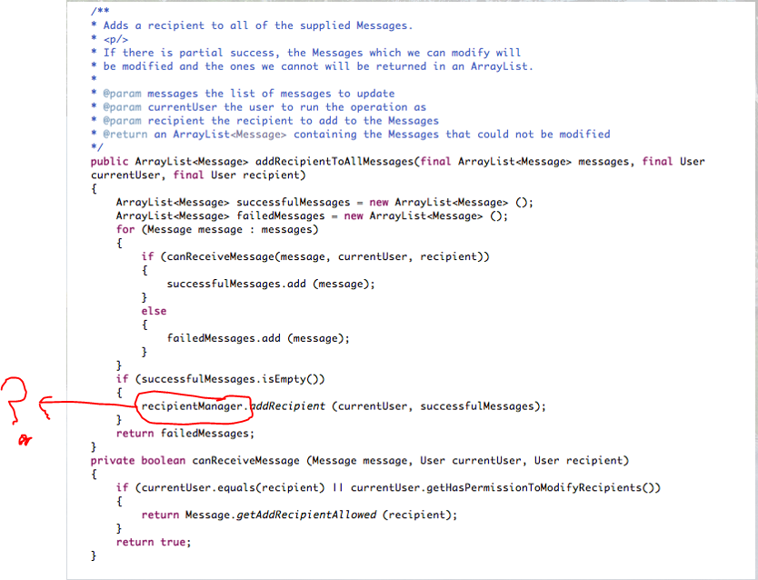

* 1. ‘message’ variable is not being used in the second method on line 34. In addition, it is un-instantiated in this script. We would need to make the second method Public instead of Private so that it can be accessed by all classes. Then we would need to instantiate ‘message’.

